Headway Wearside

Improving Life after Brain Injury

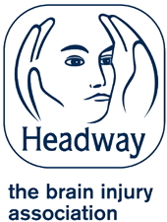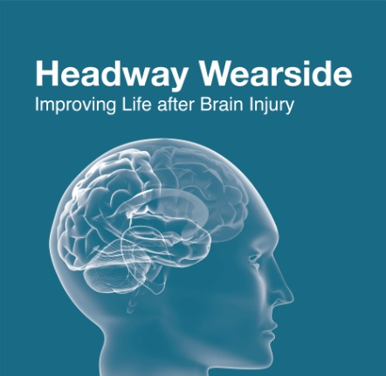Annual Report

2023 – 2024

**Headway Wearside is Registered under Charity Number: 1140910 and a company limited by guarantee registered in England no 07504702**

**“Affiliated to Headway UK, the brain injury association ”**

**Welcome**

Headway Wearside is a registered charity and company limited by guarantee, it is affiliated to Headway UK the national brain injury association.

**Chairpersons Report**

I am delighted again as Chairperson for the charity to say that Headway Wearside has continued to develop and grow the range of services and support we offer to Brain Injury Survivors and their families across Sunderland and surrounding Wearside area.

The AGM report provides a details of the various initiatives we have ran over the last twelve months. It is testimony to the work of all our staff team which currently consists of three fantastic workers Kim, Julie and Jason whom many of you will know. I must also pay special tribute to Charlotte O’Keefe who recently left the service. She was integral in allowing us to build our staff team in the Community Acquired Brain Injury Service which serves Sunderland, Gateshead and now South Tyneside also.

I must on behalf of the charity say a big thank you to Kim Hunter our fantastic Business and Community Development Manager to whom as a committee we are and remain extremely grateful. This is a role that Kim has been involved with for many years and the successes of the charity have been in a large part because of her continued drive and commitment.

I would also like to pay tribute to all the volunteers who have supported the charity either through being part of the committee, mentoring other members or by fundraising for the charity.

As a charity we continue to engage with our members and we have a number of Brain Injury survivors, carers and family members on our Trustee Board who volunteer their time and ensure that we are delivering activities and support that our members need. This holistic person-centred approach is an important part of Headway Wearside’s ethos and business plan.

As many of you will know Headway Wearside as a small local charity depends upon ongoing funding from various sources including charitable trusts, individual fundraising, company fundraising and most importantly ongoing funding from both Cumbria, Northumberland, Tyne and Wear NHS Trust, Sunderland City Council and the Local ICB [Integrated Care board]. We are therefore very thankful for the financial support we have received from all our funders whom are referenced further in our treasurers report.

I would also like to pay special tribute to all those that have been involved in fundraising for Headway Wearside. I would welcome anyone who is thinking of fundraising for us to please do so. We really do appreciate any contributions big or small to the charity.

PAUL BROWN

Chairperson of HEADWAY WEARSIDE

PARTNER AND SPECIALIST BRAIN INJURY SOLICITOR AT BURNETTS SOLICITORS

April 2024

Activity and Support Services

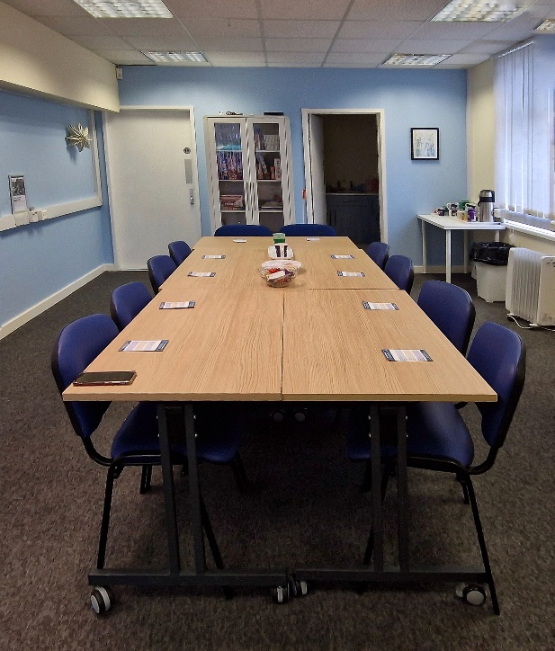Welcome to our New Building,

In May 2023 we moved to a new building, at Washington Millennium Centre, The Oval, Concord, this has brought about some fantastic changes to the way we work , We now have larger premises including our activity room. Every room is on one level making access easier.

We also have access to additional facilities such as a community gym, A free lending library, Weight Management Service, An outdoor all weather pitch . A Large Hall for games and exercise and a quiet room for relaxation, allHall

Most Wednesday mornings you will find some of our members spending their free time catching up having a game of pool[or three] grabbing a hot sandwich in the community café, and saying hi to people as they pass through on their way to the community activities.

We offer support and information in a cosy seating area with refreshments and information for survivors and their carers.

We held **234 hours of activity** time which was accessed **509 times** in addition to this we have supported individuals via face to face meetings, drop-ins, emergency and crises support, telephone support. We have completed Pip and Attendance allowance Benefit forms . We have worked alongside Adult Services within the City of Sunderland to ensure our members have everything they need to live as independently as possible with adaptations to their homes including bathrooms, handrails, ramps, grabrails and additional equipment such as wheelchairs and walkers.

We work with several organisations and partners to enable us to offer a greater range of activities and support.

**Mickeys Place** - The lunch Club at the community Café in Washington. A two course set meal is cooked and served by volunteers. Meals are back to basics good wholesome meals made with food donated by the community and local supermarkets

**Workers Education Association and The cultural spring**

Members signed up to free courses.

Art and Crafts- A range of craft sessions that are suitable for anyone to join in. including light up bottles, Christmas cards gifts and cooking sweet treats, Working with Polymer clay and taking part in the city of Sunderland Light up the Park event.by making lanterns

**At One**- provides exercises will include moveability and Strengthening exercise , Examples of exercises will include: Seated resistance band work, Seated and gentle circuit, Low weight training, exercise to music

**Sunderland Foundation of Light**

Skills sessions with a six week cooking course at the Beacon of light, learning the basics and kitchen safety and healthy eating. Some of our members went on to additional learning and were awarded a level one certificate.

**Sunderland and North Durham Society for the Blin**d – A joint funding bid enabled social integration and a course of exercise to be delivered for those with a neurological condition and sight loss/disturbance. Exercise was focused on movement and core strength using a range of equipment to make the session more fun.

**Equans Training provider, delivering team building sessions that got everyone motivated and thinking outside the box. They also put up our sign so everyone can find the new office**

**Calvert Trust Kielder – Look ahead in the North 2023**

A residential weekend with other Headway groups and branches from the North East .

Members took part in a range of activities that enabled them to learn new skills, relax in a comfortable environment, make new friends. Members choose their own activities including, boat trips, zip slides, archery, laser clay pigeon shooting, murder mystery night, quiz night, arts and craft room, relaxation therapies, talent show competition,

**Student support** – Headway Wearside believe in giving something back to the community, and to encourage the next generation of adults to have a greater and understanding and knowledge of acquired brain injury and the impact it can have on individuals and families. Because of this we work closely with schools and colleges in the are to provide work experience placements and student placements . We also attend university business events to give talks and information.

Our students have attended a range of courses including Student GPs, Student Psychologists, Work experience students.

**Support for members**

* Continued to deliver telephone and face to face support for members as required.
* Provided food vouchers for those in need who could not access local foodbanks.
* Held warm space Wednesday games and activity drop in Sessions.
* Paid for access to members own local gym for 3 months.
* Paid for Taxi and travel to attend activities or support.
* Provided subsidized trips and FREE activities.

Query Type

* Homelessness
* Housing
* Equipment
* ID Cards
* Utility Costs
* Food shopping
* Hospital appoinments[booking and help]
* Grant forms
* Access to food banks

**Support for Staff**

To enable Headway Wearside to continue to grow and develop our staff attend local, regional and national conferences such as NABIF and UKABIF,

Uptake Professional Training alongside personal development Training, They attend the North East Headway Network .

Family Support Services

**Community Acquired Brain Injury Service (CABIS)**

**Headway Family Support Officer and Headway Benefits Officer**

The Headway Service Coordinator and Headway Benefits Support Officer provide support, for those who do not require support by a psychologist, information, and support to resolve practical issues. Support with benefits and signposting to services such as Headway, CAB, Talking Therapies.

This report covers both carers and benefits support from April 2023 to March 2024.

|  |  |
| --- | --- |
| **REFERRALS** |  |
| Sunderland | 58 |
| Gateshead | 32 |
| South Tyneside | 31 |
| Total | 121 |

There have been 93 new referrals, made up of 49 from Sunderland, 24 from Gateshead and 25 from South Tyneside.

Carers are supported via telephone, home visits and carer support groups, as well as contact through email and text messages.

During this period all carers have continued to receive signposting information to local carer support services and an offer of support from both Headway officers

Referrals have ranged from family members with loved ones still in acute hospital, to carers supporting loved ones at home and struggling with the emotional or practical impact of this to people who are long term carers who benefit from support to monitor and maintain their wellbeing.

**Appointments**

We offered 87 home visits, 117 telephone appointments, 17 office appointments. Appointments are tailored the service user needs.

|  |  |
| --- | --- |
| **APPOINTMENTS** |  |
| Home Visits | 87 |
| Telephone | 117 |
| Team Base | 17 |
| Total | 221 |
|  |  |

Benefit support:

|  |  |
| --- | --- |
| **QUERY TYPE** |  |
| PIP | 50 |
| PIP Other | 11 |
| Other Benefits | 34 |
| Debt | 5 |
| Carer | 55 |
| Other Support | 42 |
| Total | 197 |

Emotional support has included:

* Providing regular ‘catch ups’ with via telephone or face to face, for chance to talk about any difficulties that they are having in their caring role or that they need an opportunity to discuss to help them to manage their stress levels.
* Providing support around anxiety and sharing CNTW self-help resources, to support carers to manage their own mental health.
* Speaking with carers to help normalise difficult feelings that they are experiencing as part of their carer role to help them see these as part of a process of coming to terms with a loved one’s injury rather than as a personal failing.
* Offering ongoing alternative support in the event of changing circumstances.

**Feedback**

*Hi Jason, Alan got PIP! Thank you so much for all your help. It's a big relief because we've heard so many horror stories about genuine people not being awarded it. I'm going to send a copy of the paperwork to the Blue Badge people ASAP. A positive start to the year.*

*Jason, want to thank you for all your help, the CABIS have been great, tell Lisa we are asking after her….*

**Case Study**

Carer support identified during home visit with patient who had historic acquired brain injury also is undergoing treatment for testicular cancer. After supporting patient with benefits advice, carer support was offered to parents. After discussing with parents and discovering several health issues, mother, wet degenerative macular, father, fibromyalgia, and other issues. I suggested applying for attendance allowance for both. Supported mother and father with Attendance Allowance application.

Further carer support was offered to both parents and being elderly and clearly having health issues of their own, they prefer the support to be given at home I form of a chat to discuss future options. A blue application will be looked at in the future.

* Attendance allowance application.
* Future carer support to be agreed.
* Further support with Blue Badge application.

**Support to Access Headway Activities.**

Headway staff continue to support CABIS service users to access support from Headway including:

* Support to apply for Headway UK ID
* Referrals to Headway Wearside for activities for their loved one and for informal carer support and groups.
* Supporting access to free gym activities

**Referrals**

We have referred clients on to a range of organisations including:

* Foodbanks, Local housing associations. Radar Key ,Blue Badge, Social Services.
* Travel, bus and taxi support. Financial Support.

Jason Sheriff , Cabis – Benefits Officer

Charlotte Okeefe, Cabis Co-ordinator

**Family Support Services – Walker Gate Park**

**Julie King - Family Support Officer at Walkergate Park Hospital**

**February 2023 – January 2024**

I am delighted to say that the Family Support Officer role is now fully embedded into Walkergate Park and I am receiving referrals from all of the wards. There are several ways for a family to access support: via a discussion at the weekly ward multi-disciplinary meetings; via a direct referral from a nurse or therapist or via a self referral - there are posters and flyers about family support around the hospital.

During this year I have worked with 77 families offering emotional support and practical information on a range of issues including: how to support someone with a brain injury; rights and entitlements; benefits and finances; support in the community; hospital discharge, planning for the future. The level of support needed is tailored to the individual family and can range from short term advice to weekly support.

In order to extend the reach of the post I have also delivered information and wellbeing sessions which have been attended by families who have not requested one to one support. I have also worked with families to develop and information pack which will be given out to all families at their first family meeting, once it is finalised.

**Case Study – Wendy (not real name), partner of a patient.**

Wendy’s son had a traumatic brain injury which resulted in significant physical and cognitive issues. Wendy had no experience of health and social care so described herself as ‘being lost.’ Wendy lived some distance away from Walkergate Park and had to get 2 buses and a metro to visit her son. Wendy was worried about the future and was very anxious. She was struggling to understand her partners brain injury and was neglecting her own wellbeing.

**Interventions**

* Weekly contact - offered emotional support to process what had happened.
* Support to understand the brain injury and the health and social care system.
* Practical advice about services and support in the community.
* Grant application to Headway to help pay for travel to and from the hospital.
* Grant application for a specialist bath.
* Benefits and advice and successful application for PIP.

**Outcomes**

* Wendy had an improved understanding of the health and social care system and was able to access appropriate support for herself and her partner.
* Wendy had a better understanding of how to support her partner.
* Improved financial situation for the couple.
* Wendy was less anxious and was doing things to maintain her own wellbeing.
* Wendy was able to discuss her feelings and felt listened to.

Just to say Thank You

The Trustees and staff at Headway Wearside would just like to thank all of our funders and supporters

* CABIS Team
* Sunderland ICB
* Cumbria, Northumberland Tyne and Wear NHS Trust
* St James Place
* Co op
* Sunderland City Council – What matters to you funding

We would also like to thank our partners, supporters, organisations and staff that we have worked with during 2023/4

Burnetts Solicitors EMG Solicitors

JSP LTD Headway Uk

Robert Whitelaw Damtech

Dawn till Dusk Crafts Washington Millennium Centre

Mickeys Place At ONE

Sunderland and North Durham Centre for the Blind WEA

The Cultural Spring Accounts Department NE

**Headway Wearside Trustees 2023-2024**

* Paul Brown – Chairman
* Ian Brown – Treasurer
* Andrew Patterson Secretary
* Gloria Finnigan
* Anthony Lambelle
* James Dowell
* Derek Nicholson
* Anne Egan

**Headway Wearside Staff 2023 – 2024**

* Kim Hunter
* Charlotte Okeefe
* Julie King
* Jason Sheriff